ASSIGNMENT 6

CURSOR OPERATION

CREATE TABLE:

create table empl(emp_name varchar(30),emp_id number,basic_pay number,con_pay number,tax number,net_sal number);

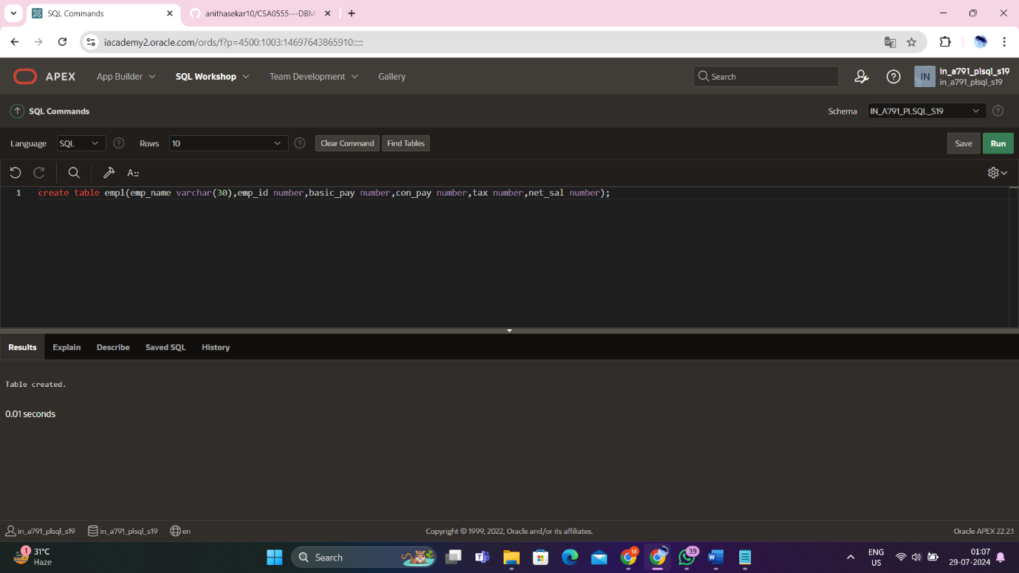

Inserting values

insert into empl(emp_name ,emp_id , basic_pay)values(‘maya’,100,30000);

insert into empl(emp_name ,emp_id , basic_pay)values(‘anjali’,101,40000);

insert into empl(emp_name ,emp_id , basic_pay)values(‘manoj’,102,50000);

insert into empl(emp_name ,emp_id , basic_pay)values(‘ananya’,103,45000);

insert into empl(emp_name ,emp_id , basic_pay)values(‘mahesh’,104,55000);

insert into empl(emp_name ,emp_id , basic_pay)values(‘moorthi’,100,60000);

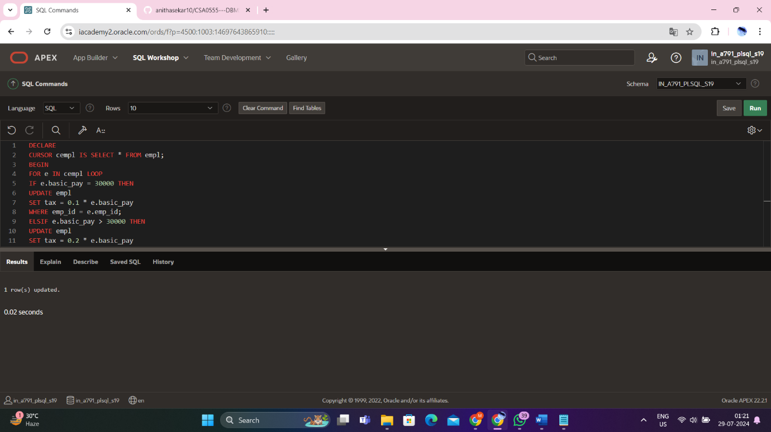

Display table

Select * from empl

